100 AI Interview Questions and Answers

With so many pseudo-data scientists cropping up due to numerous courses that offer theoretical learning, the questions in interviews is getting streamlined to filter those that understand how real-world implementation works. It is important to understand how data flows in the real world and what sort of questions are being discussed across companies.

**The value of a company lies solely in the interview process.**

Interviews across companies are growing to appreciate those that have an end-to-end understanding of how problems can be dealt with over theoretical understanding. This detailed blog is dedicated to help you understand the latest trends in the industry and how you can absorb them. Everything you will need to know for an interview will be detailed out here. We will start off with by understanding what the trends in artificial intelligence are.

Q. Have you heard of the Gartner Hype Cycle?

Gartner is a market leader in market research. The Gartner Hype Cycle Methodology is an industry-approved representation of how a technology or application will mature over time. It represents initial interest, a peak in its hype, rolls down to reduced interest in the technology followed by maturity and implementation. A lot of demand in the market comes through in two points in this cycle, in the peak and the maturity. That’s where most of the money can be made from a corporate job.

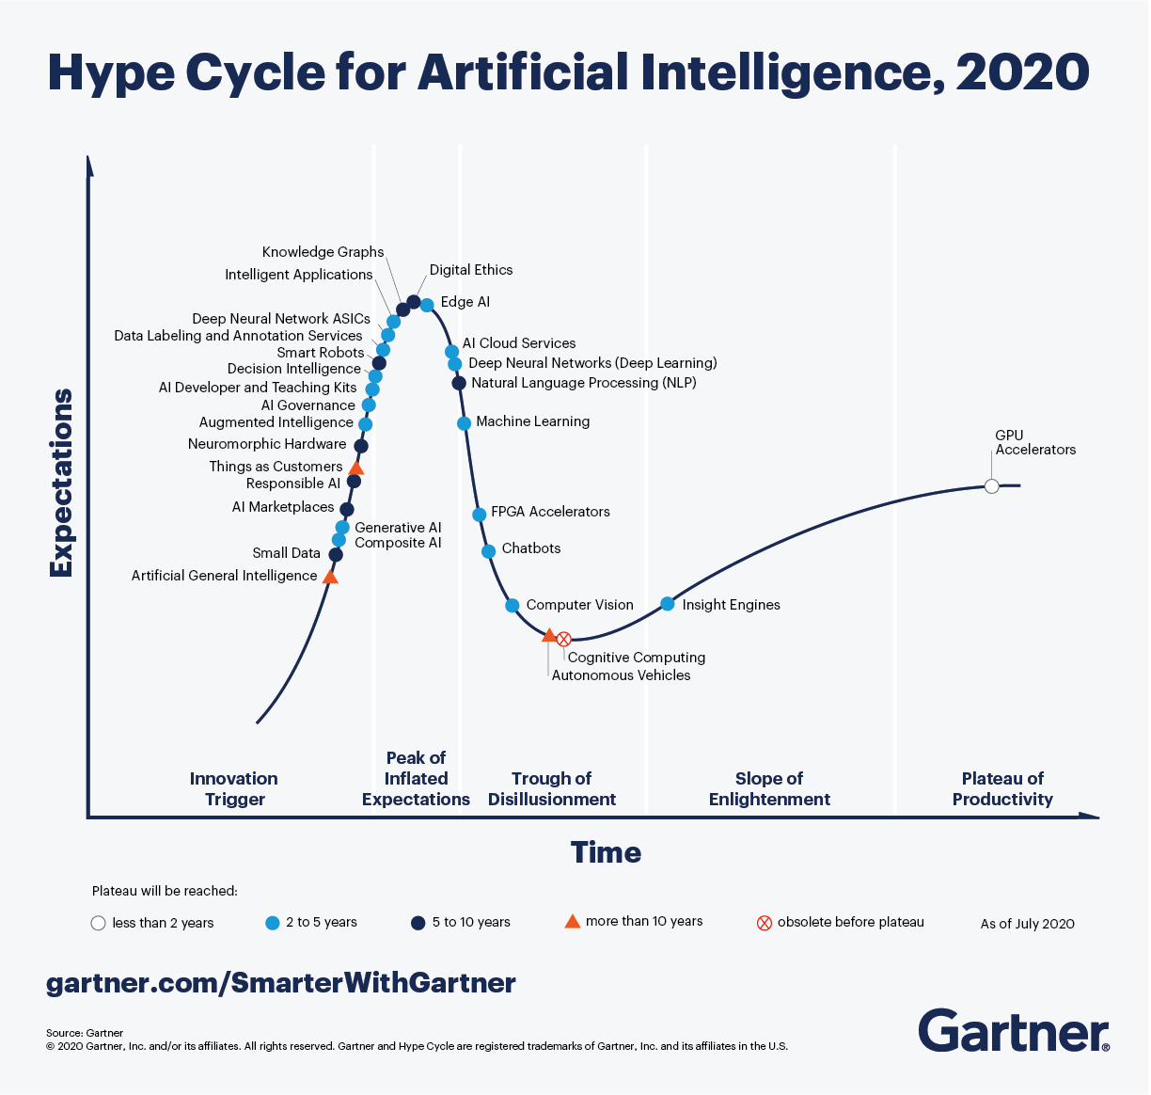  
The Gartner Hype Cycle for Artificial Intelligence ([Source](https://www.gartner.com/smarterwithgartner/2-megatrends-dominate-the-gartner-hype-cycle-for-artificial-intelligence-2020/))

Looking at the hype cycle